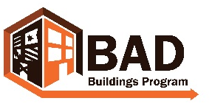 wvbadbuildings.org

Visioning

Develop a vision for your community that will include a strategy for vacant and dilapidated property. The following are some questions to consider as you develop a vision for your community.

It is important to have a vision beyond demolition. Vacant lots reduce a community’s marketability and can create health and safety issues. By establishing a vision, your community knows what priorities are important, and this will enable you to enlist help from city government and others to work toward your goals.

Remember to invite key stakeholders to the discussion. For suggestions on who to include, reference the Stakeholders tool.

Generative Questions:

- What do we like most about our community?
- What do we most want visitors to notice?
- Do we have enough of the right-sized housing to meet demand?
- Is there enough affordable housing?
- How can we make our community more attractive to business development?
- What can we do to keep our current residents?
- What do I want my community to look like once we eliminate dilapidated buildings and/or vacant lots?
- How can community groups, local government, non-profits and housing agencies work together to improve the condition of our community?

