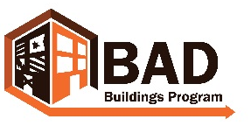 wvbadbuildings.org
Friendly Letter Template
Dear Neighbor,

My name is contact volunteer name and I am a member of the Name of BAD Buildings Team. We are a group of volunteers in Town working to improve our community by addressing its vacant, abandoned, dilapidated, and blighted buildings/properties. We are working together with all the members of our town to make it a safe and healthy place to live. Our goal is to return these properties to productivity and an asset to the community, rather than a hindrance.
We believe you may own properties we have identified as potential BAD Buildings:
- Property Address 1
- Property Address 2
- Etc.
Each individual has a role to play in making our community great and that includes maintaining their property in accordance with the laws and ordinances of our town. We understand that sometimes compliance with these laws and ordinances can be difficult so we want to contact you to learn about your plans and interests with your property. We’d also like to hear about what challenges you’re facing with your properties.
If possible, we would like to help you overcome these challenges and bring your properties back to local compliance and productive use.
Please contact me at phone number or by email at email address. I’d also like to invite you to the next Name of BAD Buildings Team meeting on DATE, TIME, LOCATION to meet the rest of the volunteers or to get involved yourself.
Sincerely,
Volunteer name
Name of BAD Buildings Team

