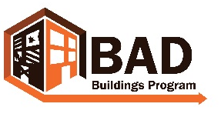 wvbadbuildings.org
Define Community Priorities
An important step in addressing blight in your community is to perform an inventory of the vacant or dilapidated properties in your neighborhood or chosen geographic area. Once that is done, it is important to prioritize the properties to determine which ones impact the community the most and require most urgent action.
This must be done in a systematic way that is as objective as possible. In order to avoid conflicts over someone feeling like their property was identified unfairly, it is important to be able to show that there was a process of selection.
How do you determine your community’s priorities? The following questions will help you to establish these priorities to be able to work toward your goals. You might also want to reference the Visioning worksheet as well.
Remember to invite key stakeholders to the discussion. For suggestions on who to include, reference the Stakeholders suggestions.
Generative Questions:
- What are some challenges that my community currently faces? Some suggestions are:
  - Criminal activity
  - Health and safety
  - Visibility of vacant / dilapidated properties
  - Concentration of vacant / dilapidated properties
  - Opportunities for economic development

- What type of change do I want to make in my community?
- What do people notice most when visiting our community?
- How can we make our community more attractive to business development?
- What can we do to keep our current residents?
Once you know your community’s priorities and have completed an inventory of the abandoned properties in your neighborhood, the next step is to prioritize the properties in the inventory. See the Prioritizing Properties Instructions and BAD Building Prioritization Grid for support on this.

